**Supplemental material for the paper ‘Homicides in Mexico increased inequality of lifespans and slowed down life expectancy gains in 2005-2015‘**

**Authors:** Redacted

**Author affiliations:** Redacted

**Corresponding author:** Redacted

**Lifespan inequality indicator**

In lifetable notation, is defined as:

where and are the survival function, the force of mortality, life expectancy, the age at death distribution at age , and the open-aged interval, respectively.

**Decomposition method summary**

The decomposition method used in this paper is based on the line integral model (Horiuchi et al 2008). Suppose (e.g. or life expectancy) is a differentiable function of covariates (e.g. each age-cause specific mortality rate) denoted by the vector . Assume that and depend on the underlying dimension , which is time in this case, and that we have observations available in two time points and . Assuming that is a differentiable function of between and , the difference in between and can be expressed as follows:

where is the total change in (e.g. or life expectancy) produced by changes in the -th covariate, . The 's in equation (2) were computed with numerical integration following the algorithm suggested by Horiuchi et al (2008). This method has the advantage of assuming that covariates change gradually along the time dimension

**Code and data to reproduce results**

Available at *(redacted to avoid identification)*

**Shinny app for sensitivity and state specific analysis**

Results with starting age 0, available at *(redacted to avoid identification)*

Results with starting age 15, available at <https://demographs.shinyapps.io/LVMx_15_App/>

**Supplemental figures. All figures are own calculations based on CONAPO (2017) and INEGI (2017) data.**

**Figure S1. Age-cause specific contributions to the changes in national life expectancy at age 15 for females. Panel A refers to 1995-2005 and panel B to 2005-2015. Note: Numbers in boxes are age-specific contributions.**

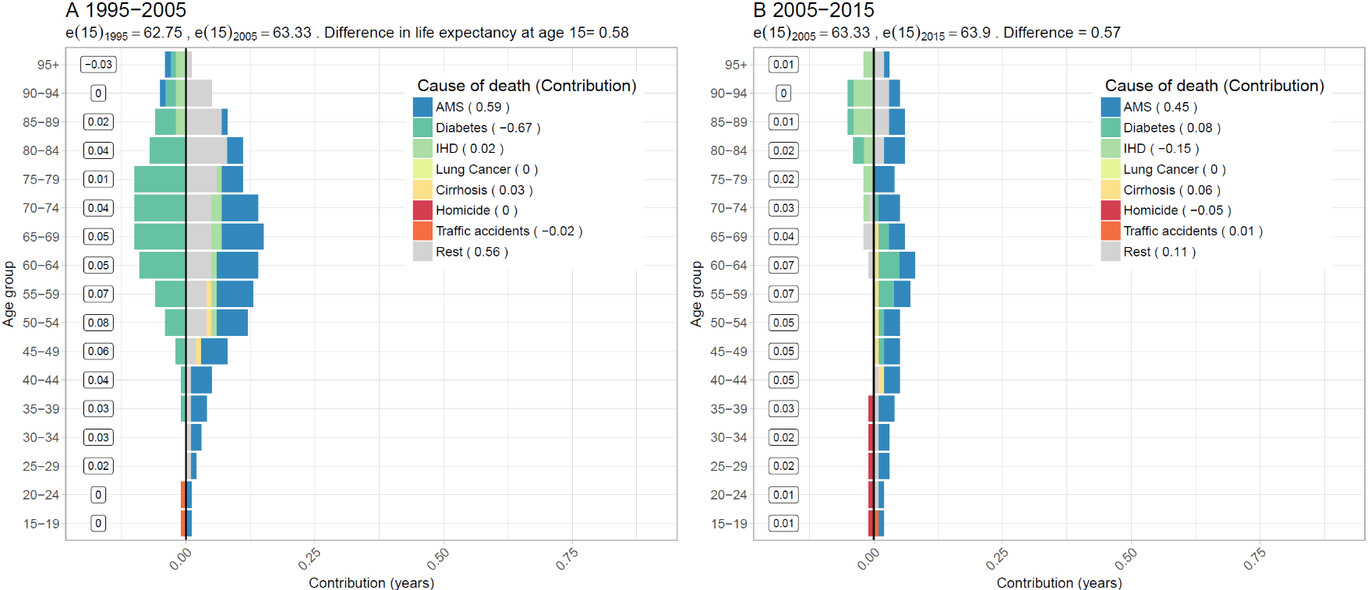

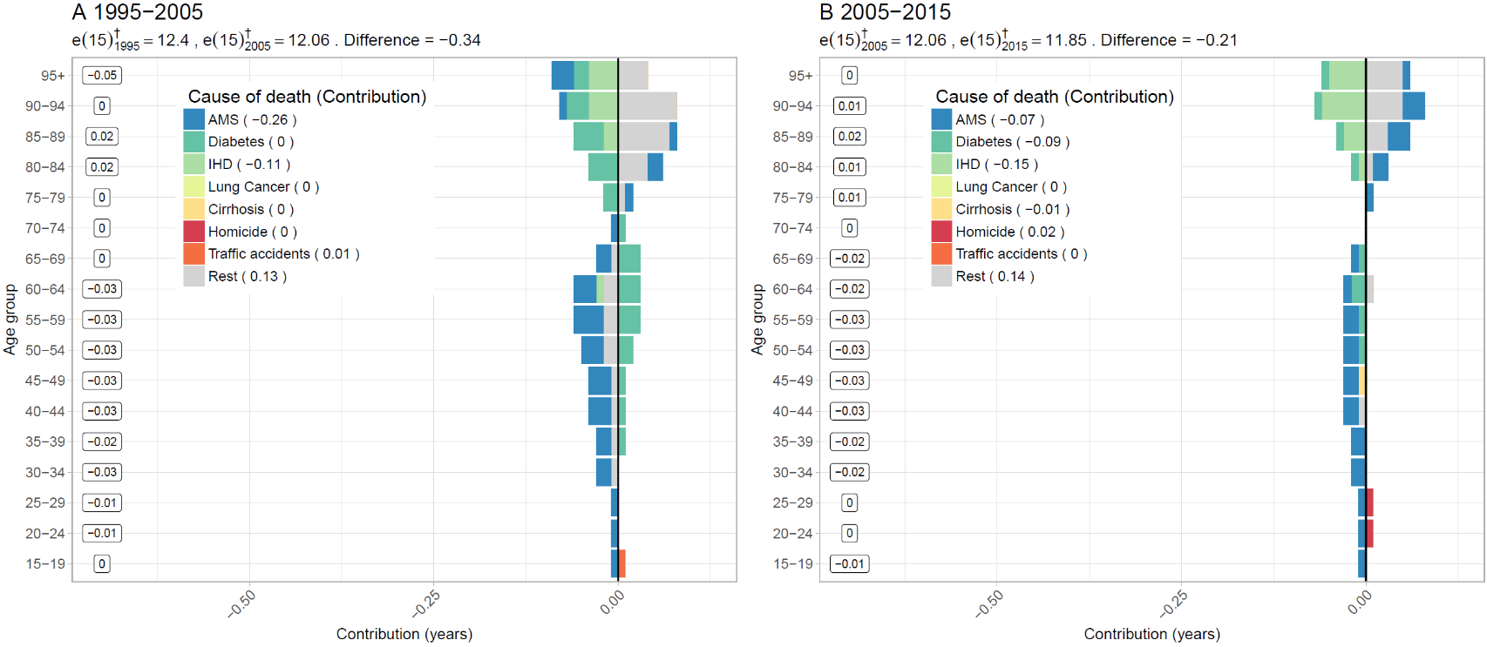**Figure S2. Age-cause specific contributions to the changes in national lifespan inequality for females. Panel A refers to 1995-2005 and panel B to 2005-2015. Note: Numbers in boxes are age-specific contributions.**

**Figure S3. Changes in male life expectancy (panel A) and male lifespan inequality (panel B)**

**by state for the periods 1995-2005 and 2005-2015.**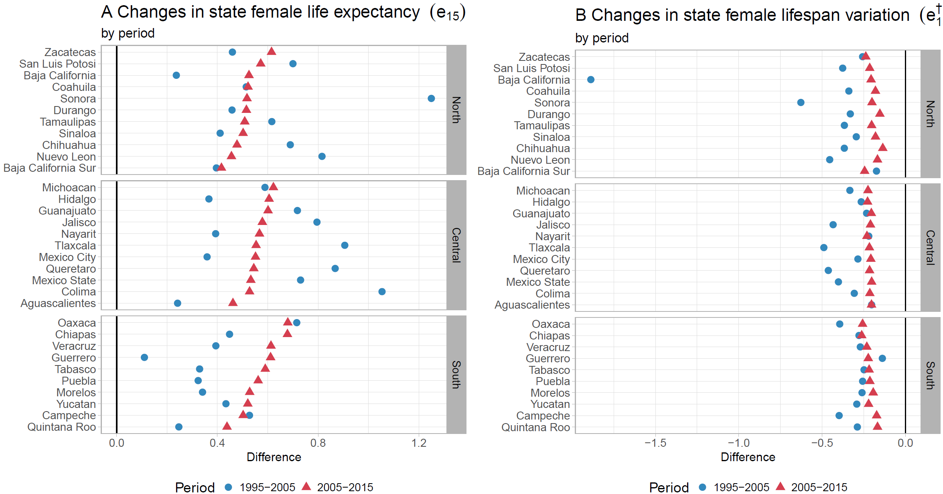

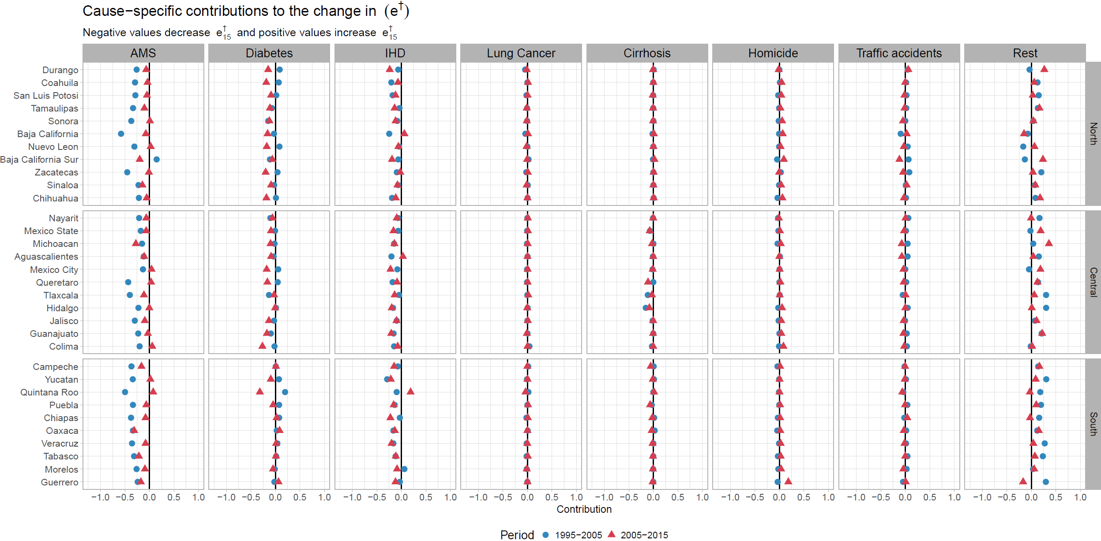**Figure S4. Cause-specific contributions to changes in female lifespan inequality at age 15 by state for the periods 1995-2005 and 2005-2015.**

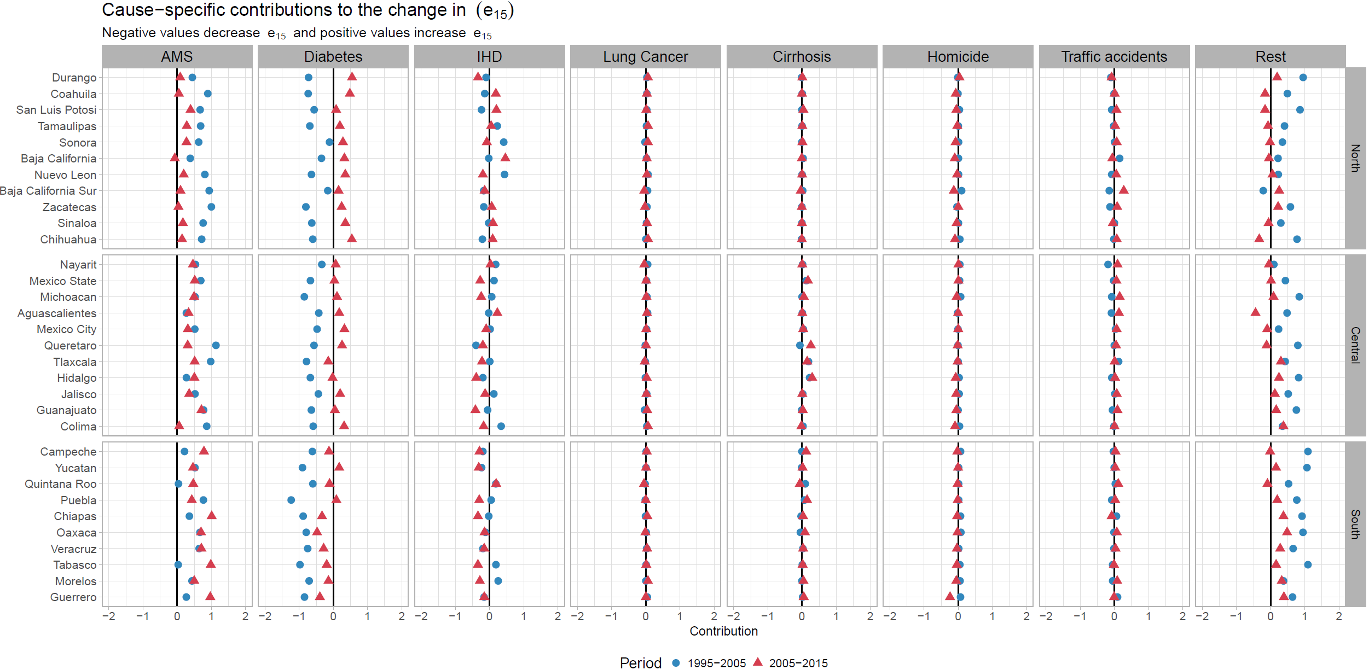**Figure S5. Cause-specific contributions to changes in female life expectancy at age 15 by state for the periods 1995-2005 and 2005-2015.**

**Figure S6. Cause-specific contributions to changes in male lifespan inequality at age 15 by state for the periods 1995-2005 and 2005-2015.**

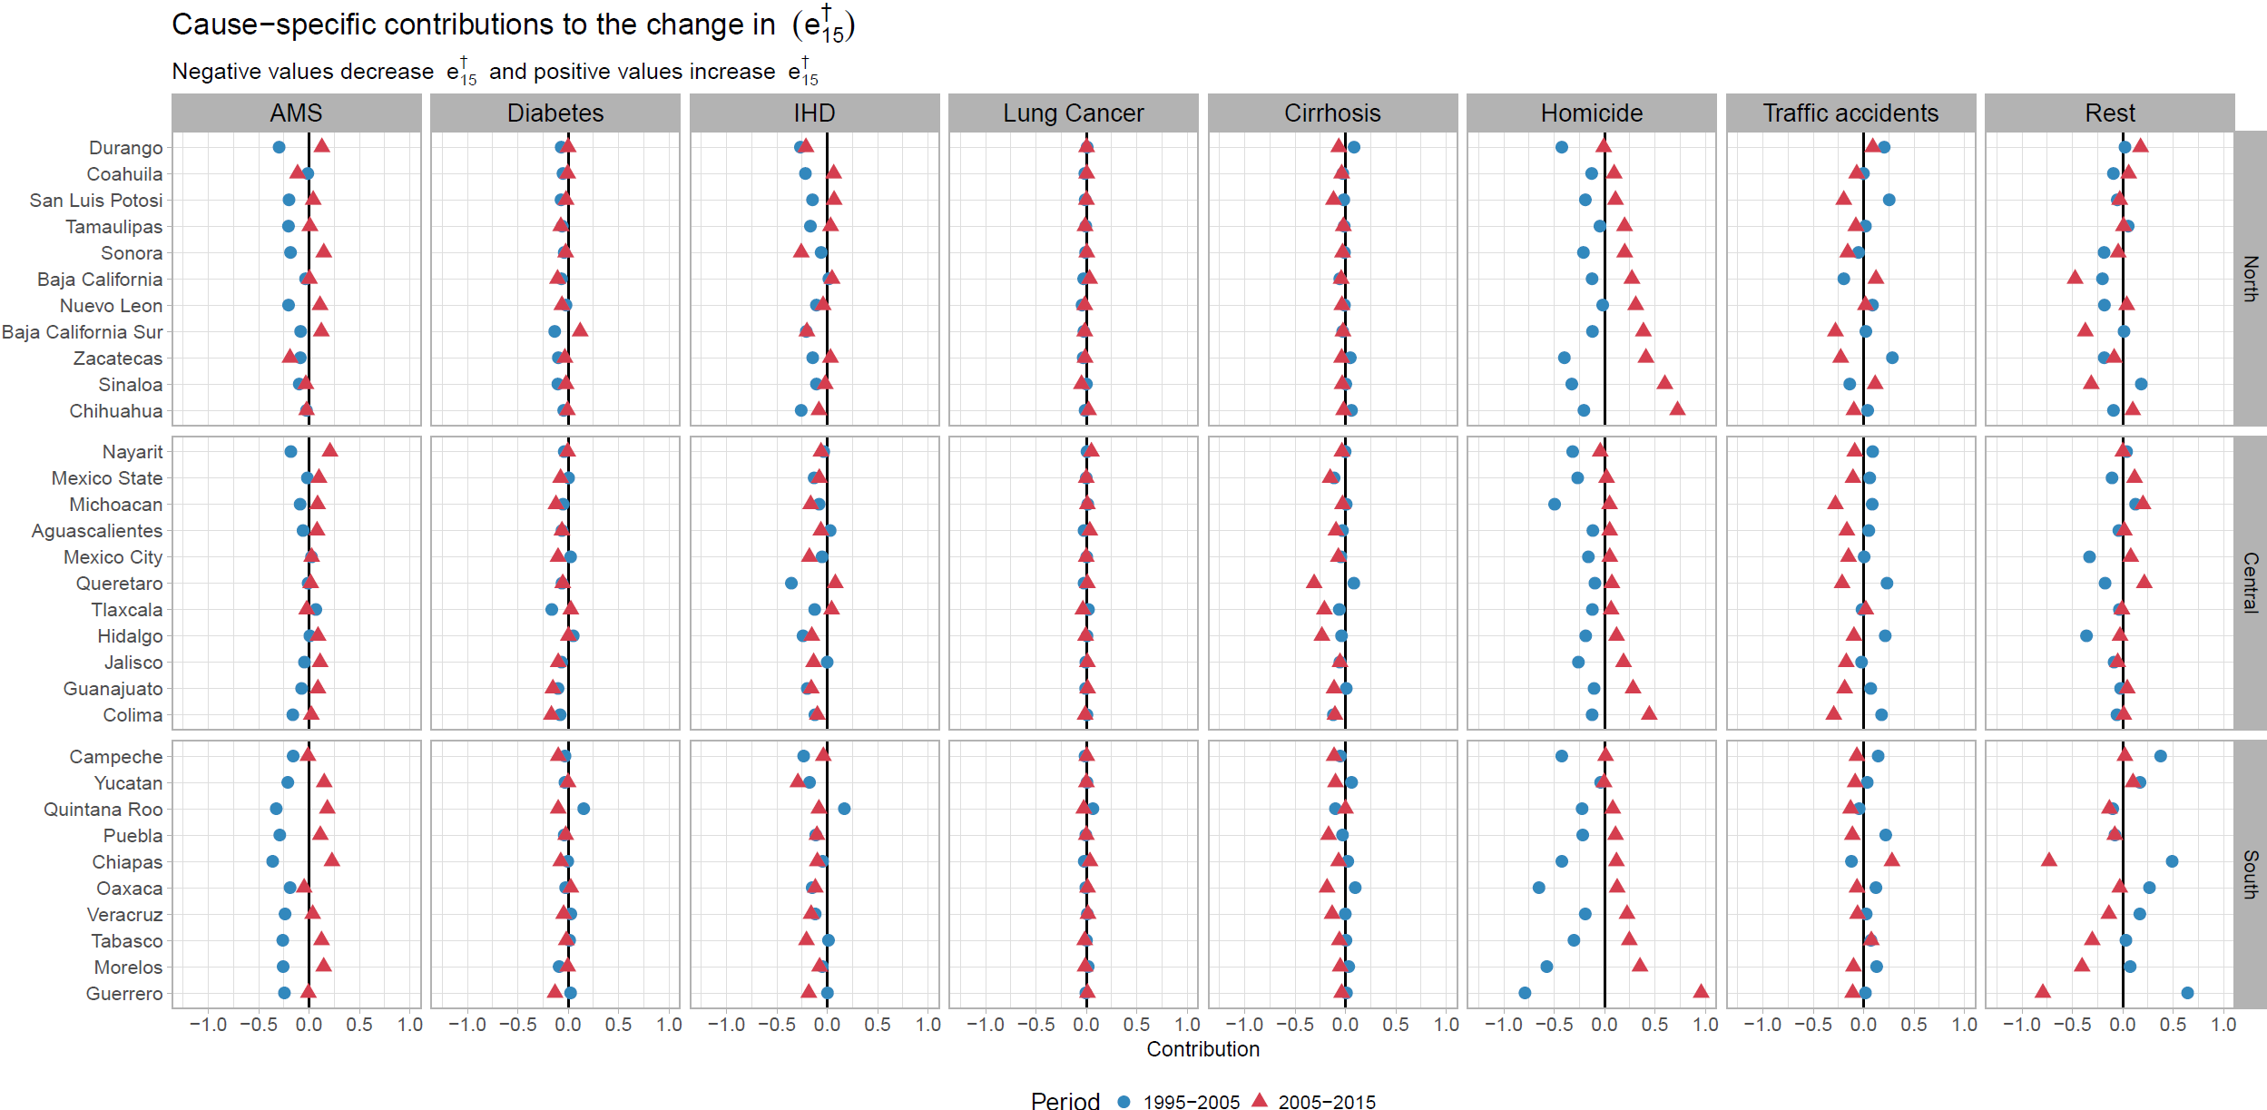

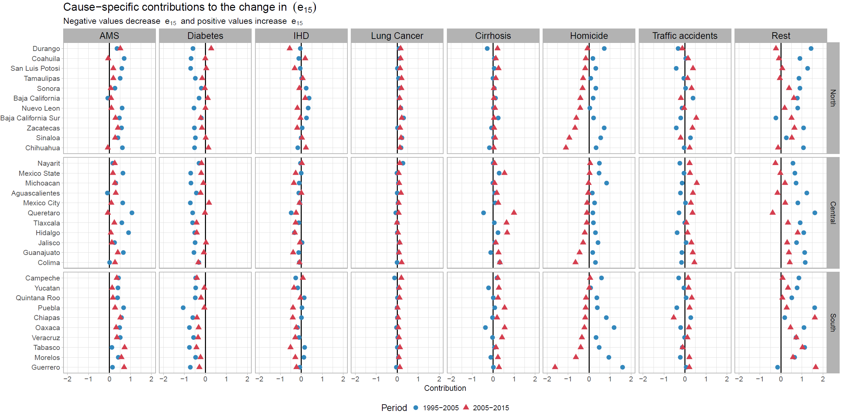**Figure S7. Cause-specific contributions to changes in male life expectancy at age 15 by state for the periods 1995-2005 and 2005-2015.**

**References**

CONAPO. (2017). Mexican Population Council: Population estimates. Retrieved from <https://datos.gob.mx/busca/dataset/activity/proyecciones-de-la-poblacion-de-mexico>

INEGI. (2017). National Institute of Statistics: Micro-data files on mortality data 1995-2015. Retrieved from <http://www.beta.inegi.org.mx/proyectos/registros/vitales/mortalidad/default.html>